IAM Patent 1000: The World’s Leading Patent Professionals 2023
IAM uses an in-house developed survey tool to enable firms to upload their submissions securely. We have taken a security-led approach to designing this tool with the confidentiality of your data as our primary consideration. The key advantages of this new approach include:
- All submission data is stored on our company servers
- The risks associated with sending sensitive content via email are removed
- Built-in password protection is provided for all firms participating in the research
- Robust access control ensures only authorised members of the IAM team will be permitted to view each submission
If you have any questions about how your data will be handled, please contact Nicholas Richardson (nicholas.richardson@lbresearch.com).

Contents
Accessing the secure online survey portal 2
Completing the survey 3
Editing a filled survey 4
Submitting a filled survey 5
After submitting 6

Accessing the secure online survey portal
- You should already have received a unique team link and password by email. If you have not received this email or have lost your login details, please contact Nicholas Richardson (nicholas.richardson@lbresearch.com).

- Upon visiting the team link for the first time, you will be prompted to enter your name and password
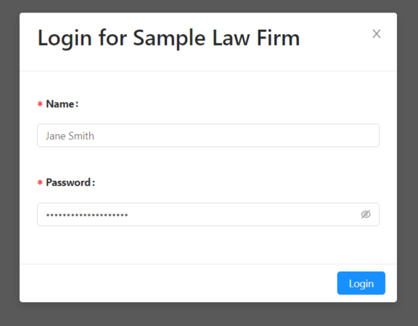

- Once logged in, you will be presented with a dashboard similar to this:
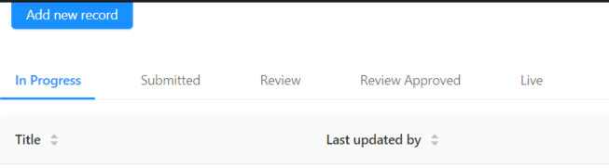
From this screen, you can view your draft or submitted submission.

Completing the survey
- To begin filling in the survey, click the blue ‘Add new record’ button.
IMPORTANT NOTE – It is possible to save your survey at any point and we recommend saving at regular intervals. To do this, please navigate to the final page of the survey and click Complete. Please be assured you will be able to make further edits after doing so.
Do not navigate away from the survey webpage as unsaved changes will most likely be lost.
Clicking Cancel will return you to the dashboard without saving any changes since the last save. Avoid clicking this button unless you are sure you wish to discard any changes.
- The first page of the survey contains instructions on filling in the survey. Please read this page carefully. When you’re ready, click Next to begin completing the survey.
IMPORTANT – MARKING CONFIDENTIAL INFORMATION – The survey has been designed to allow you to mark your responses to most questions partially or wholly as confidential.
To do this within a text field, select the text you wish to make confidential and change the background colour to yellow, as shown in the image below.
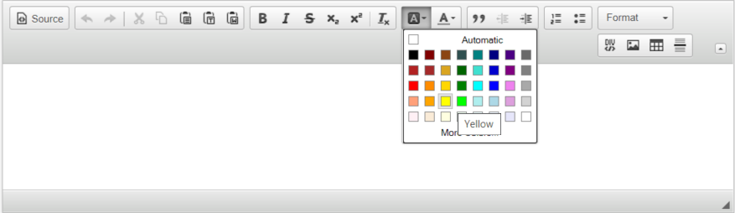

- Certain questions, including those concerning work highlights, are completed using a mini-dashboard within the survey.
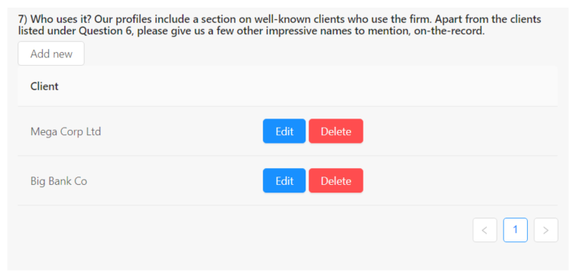
Click ‘Add new’ to create a new entry. In the popup that appears, enter all applicable details and click Complete to save the entry. Clicking out of the popup or the X in the top corner will close the window without saving.

You can update a created entry by clicking Edit or remove it by clicking Delete.
10 entries are displayed per page within the dashboard. Use the arrows or page numbers to browse.

- When finished completing the survey, click Complete. You will receive a message saying the save was successful.

- Your created survey should now be visible in the dashboard under the ‘In Progress’ tab. If it is not, please try refreshing the page.

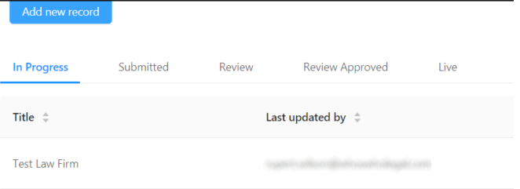

- IMPORTANT – Your submission is not yet considered submitted. Please follow the steps outlined below to finalise submission.

Editing a filled survey
- On the dashboard, use the Action buttons to the right of your entry to make changes to your filled in submission.

- Clicking Edit will return you to the survey form and allow you to make changes.
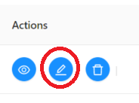

- To delete your submission, click the Delete button. IMPORTANT – this cannot be undone.

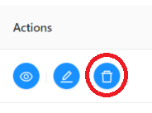

Submitting a filled survey
- When you are ready to submit, click the View button.
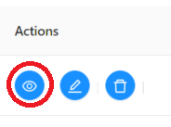
- On the survey form, you will now see the following options at the top and bottom of the page.

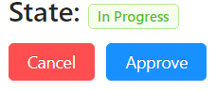

Clicking Cancel will return you to the Dashboard.

Click Approve to finalise your submission. You will be prompted to Confirm the Approval and will then receive a message saying the submission has been successfully accepted.

- On the dashboard, your completed survey will have disappeared from the ‘In Progress’ tab and will instead appear under the ‘Submitted’ tab.

After submitting
- Once you have submitted your survey, you can view it at any time by logging into the portal and navigating to the ‘Submitted’ tab.

- It is not possible to edit or delete a submission once it has been submitted. If you wish to make any edits, please email Nicholas Richardson (nicholas.richardson@lbresearch.com) and your submission will have its status returned to ‘In Progress’, after which you will be able to make changes.

- When you have finished making edits, please ensure you resubmit the updated version by following the steps above.

